INSY5336-Lab 1

Student Name: Prem Atul Jethwa

Question 1.

Chapter 3, Programming Exercises: 1. (Page # 151)

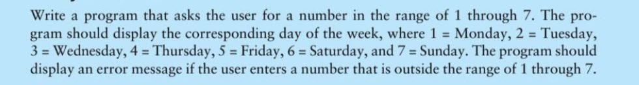

Question 2.

Chapter 3, Programming Exercises: 3. (Page # 152)

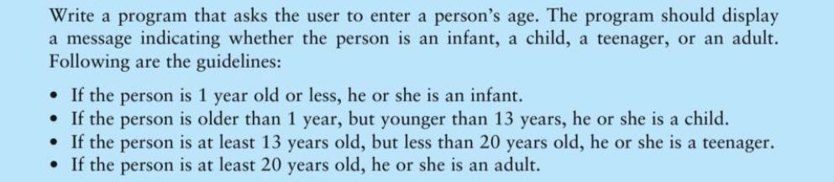

Question 3.

Chapter 3, Programming Exercises: 12. (Page # 154)

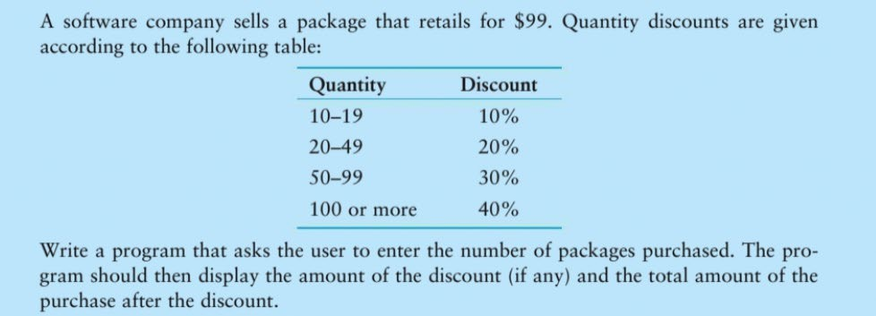

Question 3.

Chapter 3, Programming Exercises: 12. (Page # 154)

Question 4.

Chapter 4, Programming Exercises: 6. (Page # 204)

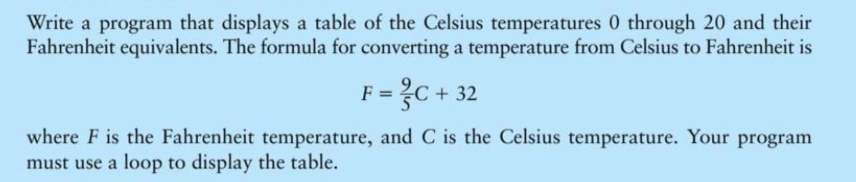

Question 5.

Chapter 4, Programming Exercises: 12. (Page # 205)



